# The Booking System and Intermediate Stops

Intermediate stops add a whole new layer of fun to online booking... Mostly for me, but there are some inevitable complications for the guards as well so I have tried to make this as simple as possible.

Firstly, you will note that with all stations open, the list of departures, now has options for every station:

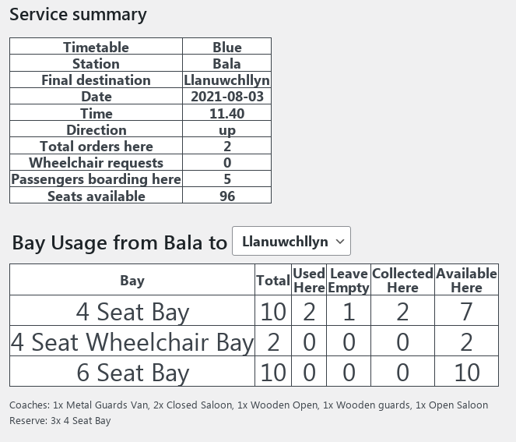Tapping on each time gives a familiar summary, but with some enhancements. Eg for the 11.40am from Bala:

The numbers are all adjusted for the station you are "at" (if you work on the assumption that the guard will sensibly choose the correct departure from the correct station!). I've reinforced this by saying "here " after most of the numbers.

* **"Used Here"** is the number of bays of each type that you will have full at departure if the train is loaded according to the bookings made. (as before)
* **"Leave Empty"** is the number of bays that of each type that need to be empty when you depart from the chosen station in order to accommodate bookings at Llangower. **It is very important to pay attention to this column when trains are busy.** This number will be offset to account for people getting off at Llangower. eg if you are at Llanuwchllyn and have passengers in 3 x 4 seats bays going to Llangower and there are passengers getting on at Llangower going to Bala that will need 4 x 4 seat bays, the “Leave empty” column for 4 seats bays will show 1, since only one additional bay will be needed at Llangower to accommodate the waiting passengers.
* **"Collected Here"** is the number of orders originating from this station, or people already on the train at this station that have been collected. If everybody is on board who is expected, it will match the "Used Here" value.
* **"Available Here"** is the number of bays you can sell.

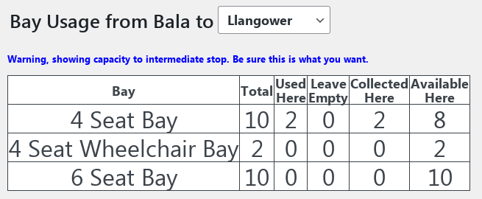There is a drop down box for Bay usage from the current station to a selectable destination. This will default to the terminus. However, if you are at Bala and have somebody wanting to go to Llangower and you want to check space only as far as Llangower, you can use the drop down to give the correct calculation. eg:

Note that "Leave empty" 4 seat bay now shows as available to sell, this is because there are more Llangower - Llanuwchllyn bookings on this train than Bala Llangower. If you were to choose Pentrepiod as the destination, the leave empty seat comes back, because of the greater number of Llangower-Llanuwchllyn passengers.

If you are unsure if capacity is available, just start a manual booking in the normal way, the booking system wi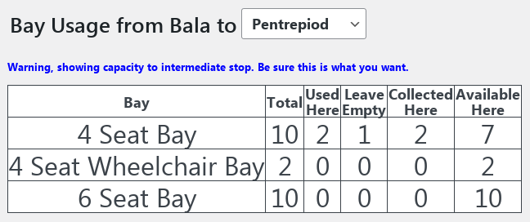ll tell you if the passengers can be fitted in.

The orders summary now has multiple sections, so in addition to seeing the orders from the station you are currently at, it will also show you the orders for the following stations your train will call at/pass.

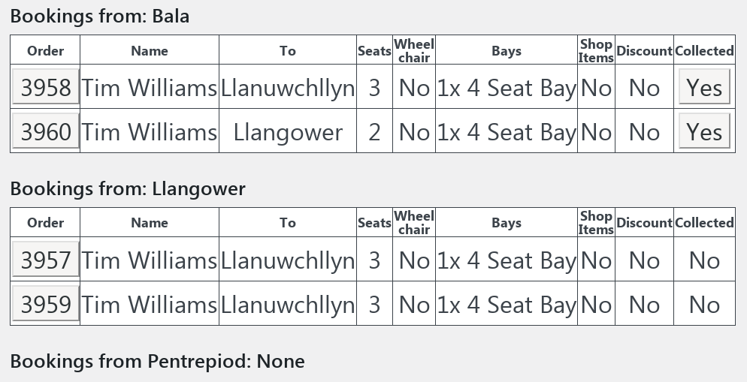

The orders total at the top will only count the orders from your current station, not those from following station which are shown for reference, to further confirm the space that needs to be set aside.

# Summaries at Intermediate Stops

When looking at the summary page for an intermediate stop, bookings from preceding stops are not shown. The assumption is that these are no longer of interest, hopefully they are all on the train!

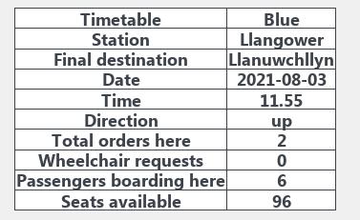

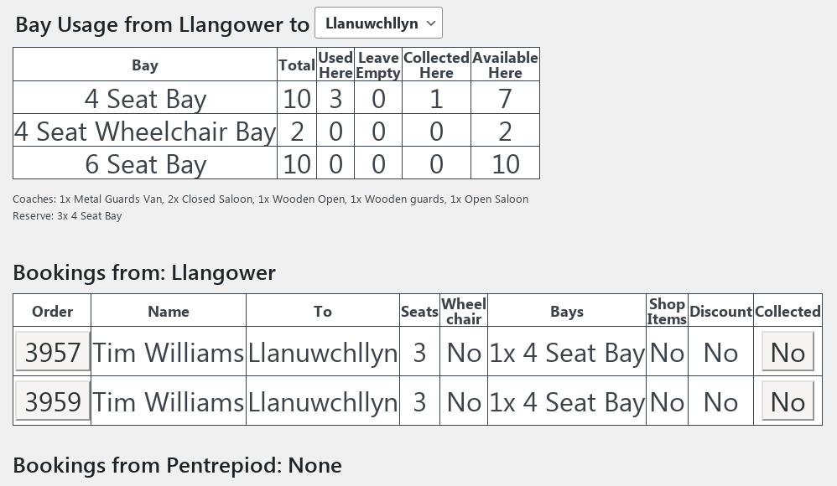

Note that this summary does not Note that the "used here" count reflects both the people getting on at this station and those already onboard (whose orders are not shown). The "collected here" count will also reflect the people on the train, so already shows the through passengers (Order 3958 on the earlier image) as collected.

# Booking Tickets

Manual bookings will work in much the same way as before. Llangower will show up as additional station options when choosing a journey, though with smaller buttons:

Train time and ticket selection will be as before, with the correct prices and tickets being automatically selected.

Passengers can book a full round trip from Llangower, but passengers starting at Bala or Llanuwchllyn on full line tickets CANNOT break their journey at Llangower.  To do this they must book a t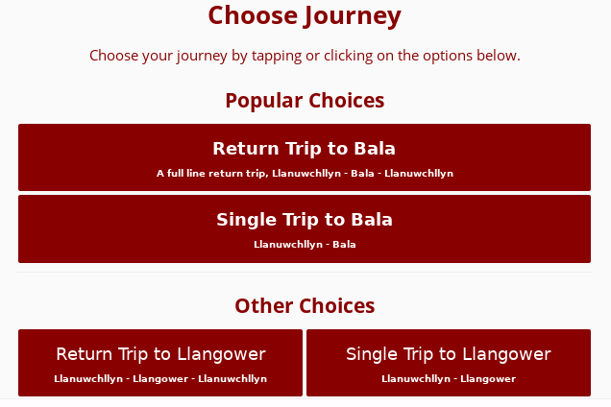icket to Llangower, then separately book a ticket from Llangower to the other end of the line, making sure the timings are compatible if they are returns.  Guards should suggest that passengers do this themselves online. Similarly those wanting, for example, to do Llangower to Bala and end up at Llanuwchllyn will need to book separate single tickets.

**Other points to note:**

* **Pre booked passengers only, no holding things up doing manual bookings at Llangower.**
* **For round trips, the full set of ticket options will be available (family etc)**
* **Discount codes will only apply to the full line round trip fares.**
* **Pentrepiod is showing on the booking system but is marked as closed, to discourage people from trying to use the station or book tickets from another station and then try to board there. (this has happened occasionally for Llangower this year).**

### Full Line Round Trips from Llangower

Full line round trip (aka Llangower - Bala - Llanuwchllyn - Llangower) are being sold at the same fare as a full line return trip from Bala or Llanuwchllyn (as normal).

The following page includes screen shots showing how full line round trips are presented to customers and in the guards interface. When booking, the first choice determines the initial direction of the round trip and that is followed by departure selection with 3 columns rather than the normal two. On the guards screen, you will simply see a booking with three legs instead of two.

